

External Documentation

Developers: Akhil Thakkar, Mayank Raval

COMP2007

Project 1 “AM Gamer”

[VIEW IT LIVE](http://amgamer3.azurewebsites.net/)

[GITHUB LINK](https://github.com/mayankraval/AMGamerPart3)

**Table of Contents**

Description……………………………………………………….Pg3

Version History…………………………………………………Pg4

Wireframe…………………..…………………...................Pg3-5

Screen Captures……………………………………………....Pg6

**Description**

* AM Gamer site is a Website build to track 4 game’s scorecard. It has the home page which displays the game dashboard where an anonymous user can see the game statistics but cannot edit it until it is logged in. Game dashboard consists of 4 different game which are Basketball, Football, cricket and Baseball. And the score card will show who is winning and who is losing i.e. game stage with the top player and Total score per week. So, the anonymous user can see the games played every week and description of the game.
* Moreover, we have also added an extra little feature where a user logs in and can see the rest of the menu, also besides the contact us, it shows the user name of user logged in.
* Once, the user logs in, it can edit the game which are already added and also lets the user to delete it. From the Edit Game Page user can access add game page if it wants to add a new game. Respectively, edit team page and edit game score page are similar where user can edit teams, game score and also lets user to add new too.
* Furthermore, if an admin logs in, it lets the admin see the registered user list and also let it edit the username, email address and phone number.
* If it is a new user, he/she can register it by register page and also contact us if the user has any questions related to the site or any other issues.

**WIREFRAME**

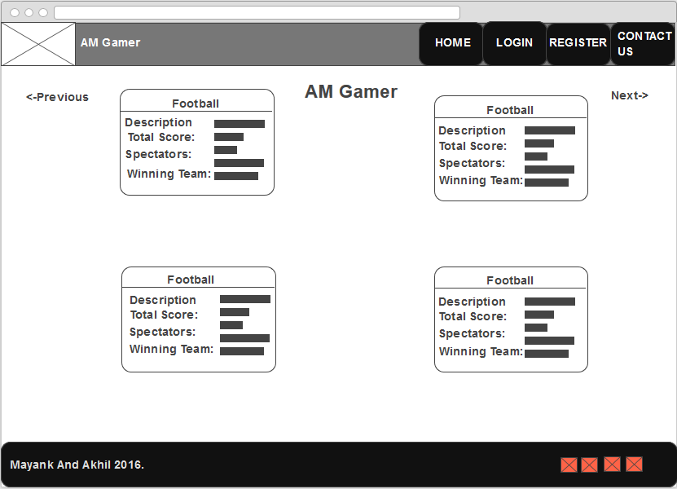

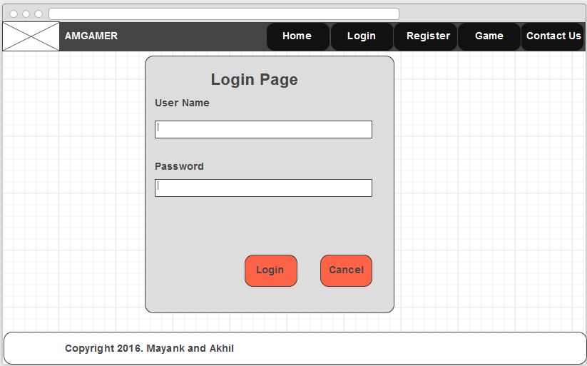

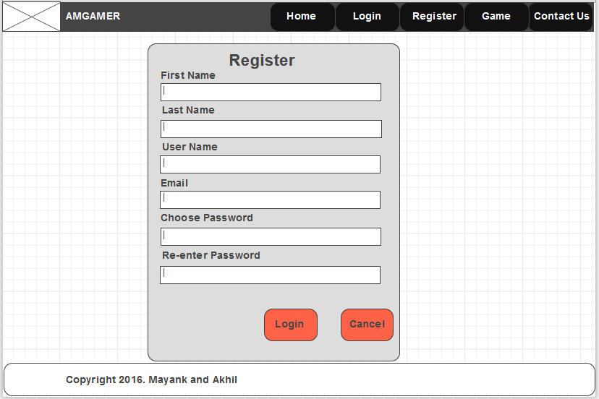

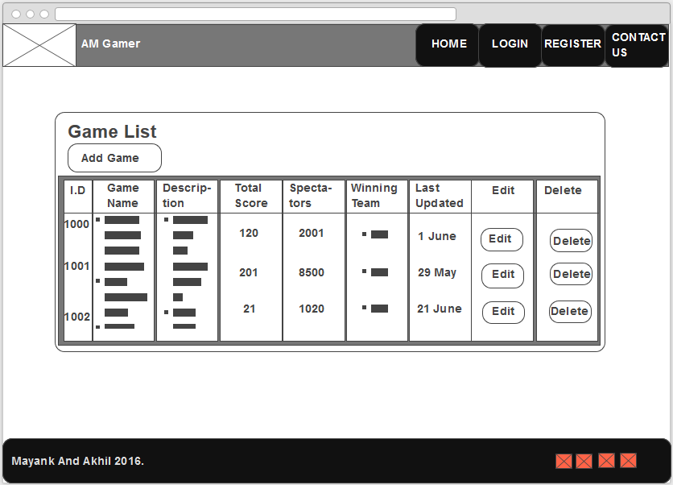

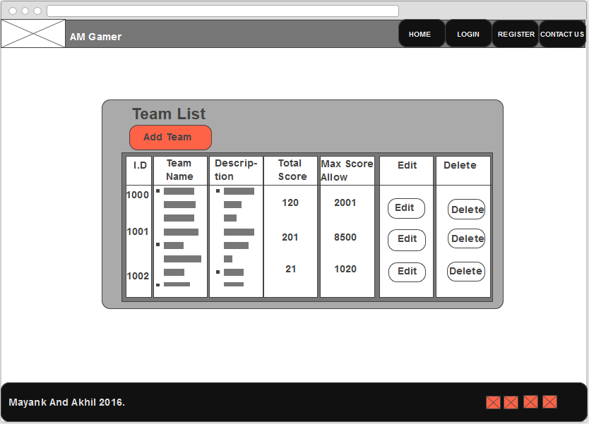

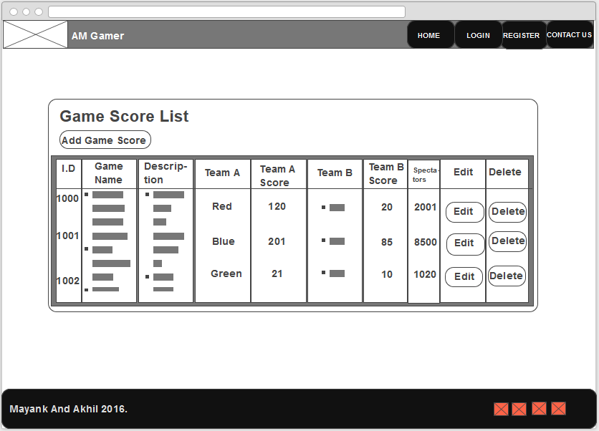

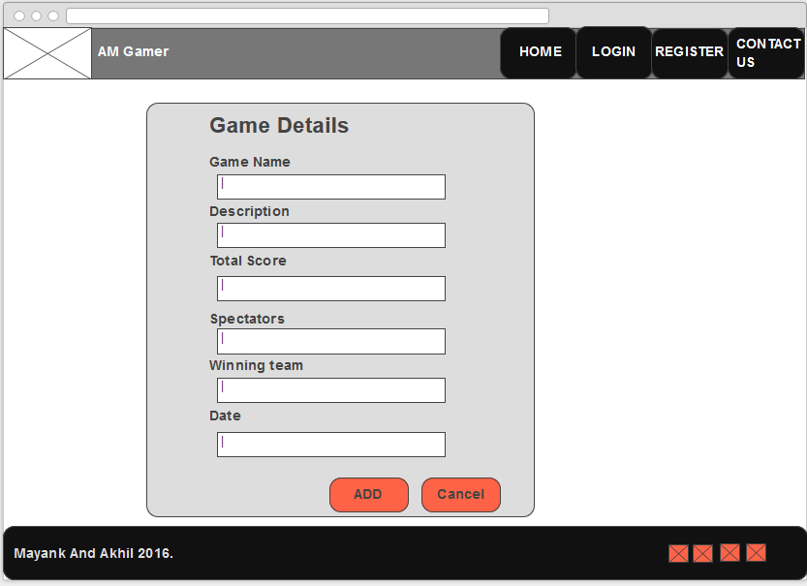

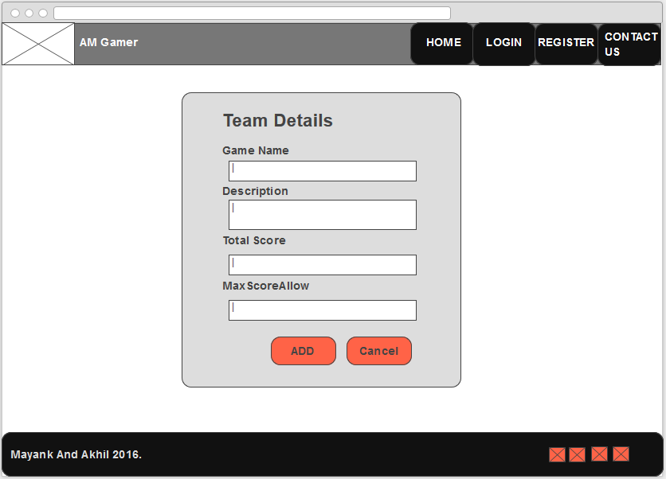

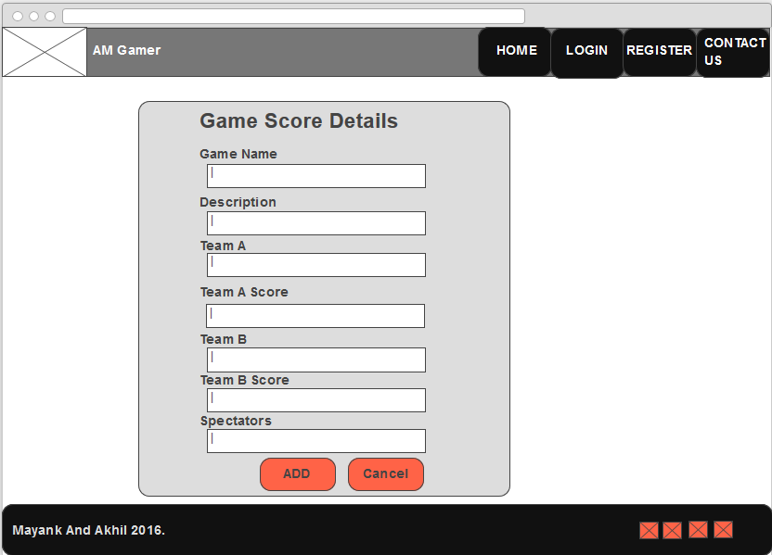

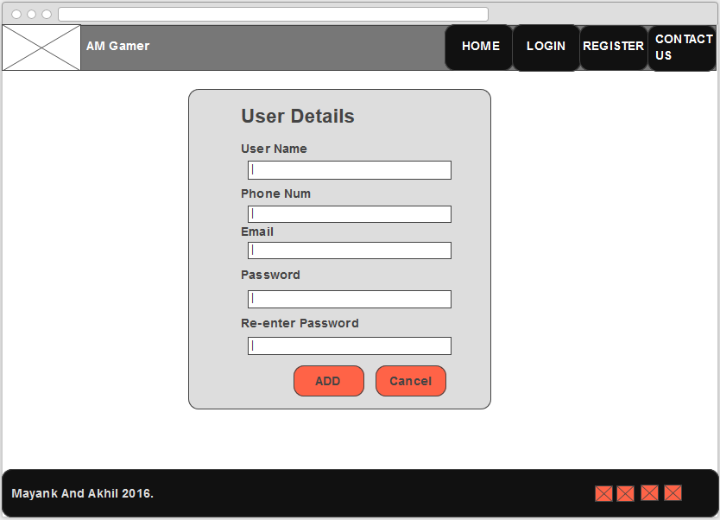

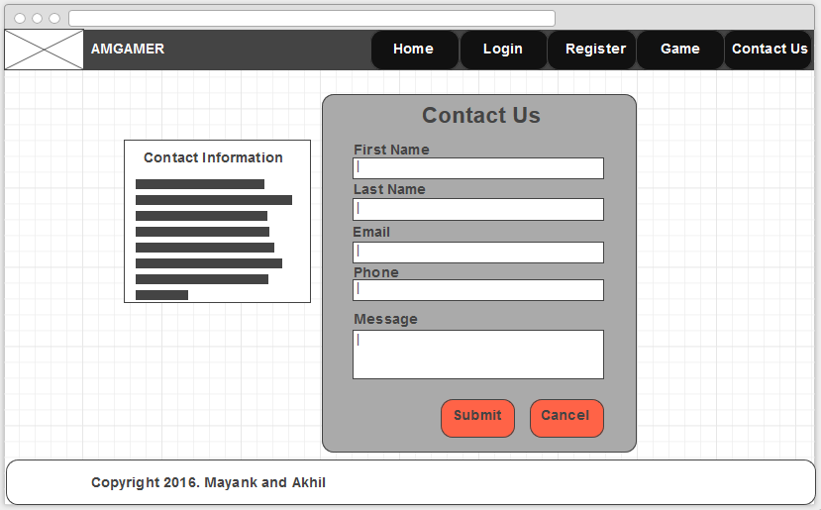

**SCREEN SHOTS**